**Assignment No: - 14**

**Q. Write ASP.NET Program to Display Record from Database Using Data Reader Object.**

**DemoDatareader.aspx**

<%@ Page Language="C#" AutoEventWireup="true" CodeBehind="DemoDatareader.aspx.cs" Inherits="WebApplication1.DemoDatareader" %>

<!DOCTYPE html>

<html xmlns="http://www.w3.org/1999/xhtml">

<head runat="server">

<title></title>

</head>

<body>

<form id="form1" runat="server">

<div>

<table class="auto-style1">

<tr>

<td colspan="2" style="text-align: center">

<asp:Label ID="lblhead" runat="server" Text="Student Information"></asp:Label>

</td>

</tr>

<tr>

<td class="auto-style3">&nbsp;</td>

<td>&nbsp;</td>

</tr>

<tr>

<td class="auto-style6">

<asp:Label ID="lblroll" runat="server" Text="RollNo"></asp:Label>

</td>

<td class="auto-style2">

<asp:TextBox ID="txtroll" runat="server"></asp:TextBox>

</td>

</tr>

<tr>

<td class="auto-style6">

<asp:Label ID="lblname" runat="server" Text="Name"></asp:Label>

</td>

<td class="auto-style2">

<asp:TextBox ID="txtname" runat="server"></asp:TextBox>

</td>

</tr>

<tr>

<td class="auto-style6">

<asp:Label ID="Lblclass" runat="server" Text="Class"></asp:Label>

</td>

<td class="auto-style2">

<asp:TextBox ID="txtclass" runat="server"></asp:TextBox>

</td>

</tr>

<tr>

<td class="auto-style6">

&nbsp;</td>

</tr>

<tr>

<td class="auto-style6">

<asp:Label ID="lblconNo" runat="server" Text="Contact No"></asp:Label>

</td>

<td class="auto-style2">

<asp:TextBox ID="txtconNo" runat="server"></asp:TextBox>

</td>

</tr>

<tr>

<td class="auto-style6">

<asp:Label ID="lblEmail" runat="server" Text="Email ID"></asp:Label>

</td>

<td class="auto-style2">

<asp:TextBox ID="txtemail" runat="server"></asp:TextBox>

</td>

</tr>

<tr>

<td class="auto-style4">&nbsp;</td>

<td class="auto-style5">

<asp:Label ID="lblmessage" runat="server"></asp:Label>

</td>

</tr>

<tr>

<td class="auto-style4">

<asp:Button ID="btninsert" runat="server" OnClick="btninsert_Click" Text="Insert" />

</td>

<td class="auto-style5">&nbsp;

<asp:Button ID="btnsearch" runat="server" OnClick="btnsearch_Click" Text="Search" />

&nbsp;</td>

</tr>

</table>

</div>

</form>

</body>

</html>

**DemoDatareader.aspx.cs**

using System;

using System.Collections.Generic;

using System.Linq;

using System.Web;

using System.Web.UI;

using System.Web.UI.WebControls;

using System.Data;

using System.Data.SqlClient;

namespace WebApplication1

{

public partial class DemoDatareader : System.Web.UI.Page

{

SqlConnection con = new SqlConnection(@"Data Source=(LocalDB)\v11.0;AttachDbFilename=C:\Users\hp\Desktop\9568\WebApplication1\WebApplication1\App_Data\StudentDB.mdf;Integrated Security=True");

SqlCommand cmd;

SqlDataReader dr;

protected void Page_Load(object sender, EventArgs e)

{

}

protected void btninsert_Click(object sender, EventArgs e)

{

con.Open();

string s = "insert into Studentinfo (RollNo,Name,Class,ContactNo,EmailId) values ('" + txtroll.Text + "' ,'" + txtname.Text + "','" + txtclass.Text + "','" + txtconNo.Text + "','" + txtemail.Text + "')";

cmd = new SqlCommand(s, con);

cmd.CommandType = CommandType.Text;

try

{

int result = cmd.ExecuteNonQuery();

if (result > 0)

{

lblmessage.Text = " Save Student Details";

}

else

{

lblmessage.Text = "Failed to ave student Details.....!!";

}

}

catch (SqlException ex)

{

lblmessage.Text = ex.Message;

}

finally

{

con.Close();

}

txtroll.Text = "";

txtname.Text = "";

txtclass.Text = "";

txtconNo.Text = "";

txtemail.Text = "";

}

protected void btnsearch_Click(object sender, EventArgs e)

{

string s = "select * from Studentinfo where RollNo = '" + txtroll.Text + " ' ";

con.Open();

cmd = new SqlCommand(s, con);

cmd.CommandType = CommandType.Text;

try

{

dr = cmd.ExecuteReader();

if (dr.Read())

{

txtroll.Text = dr[0].ToString();

txtname.Text = dr[1].ToString();

txtclass.Text = dr[2].ToString();

txtconNo.Text = dr[3].ToString();

txtemail.Text = dr[4].ToString();

lblmessage.Text =" Roll Number " +txtroll.Text + " Student Record Found";

}

else

{

lblmessage.Text = "No Record Found..!";

}

dr.Close();

}

catch (SqlException ex)

{

lblmessage.Text = ex.Message;

}

finally

{

con.Close();

}

}

}

}

**\*\*\*\*\*\*\*\*\*\*\*\*\*\*\*OUTPUT\*\*\*\*\*\*\*\*\*\*\*\*\*\***

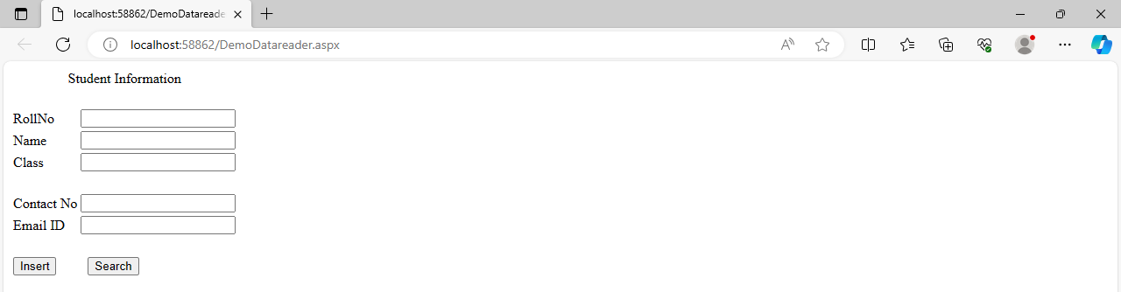

**1)Insert Record**

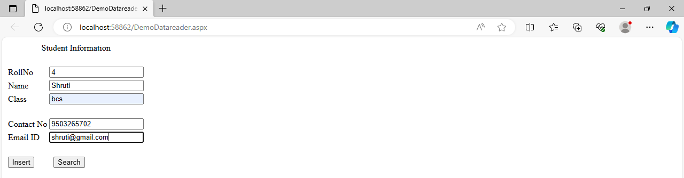

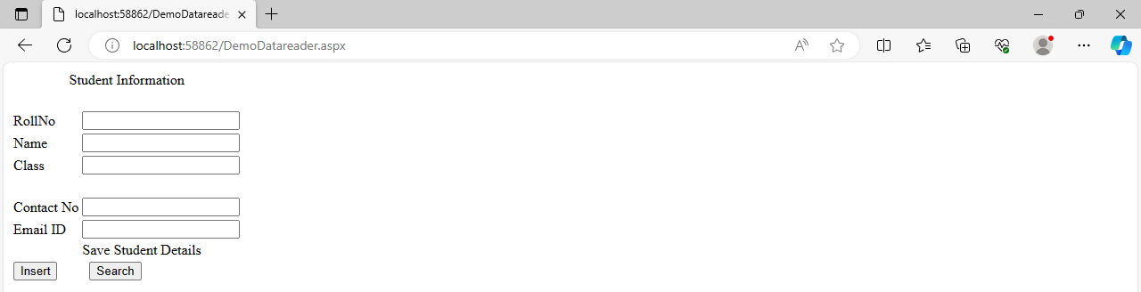

**2)Search Record**

